

SCHOOL OF INFORMATICS & IT

Diploma in Information Technology

Part 4a: Continuous Integration/ Continuous Deployment (CI/CD) –
Monitoring & Additional features

Student Name (Matric Number) : aniq amir (2300127D)

Tutorial Group : PC03
Jenny LING (TP)
Tutor : Mr Ryan Justin

Submission Date : 9/2/2025

Declaration of Originality

I am the originator of this work and I have appropriately acknowledged all other original sources used as my references for this work.

I understand that Plagiarism is the act of taking and using the whole or any part of another person’s work, including work generated by AI, and presenting it as my own.

I understand that Plagiarism is an academic offence
and if I am found to have committed or abetted the offence of plagiarism in relation to this submitted work, disciplinary action will be enforced.

Note to Tutor: This page is only to be used if your subject specifically allows AI-generated content to be used. Please delete this page if it is not required.

Declaration on the use of Generative AI tools for assignments

Describe how you have used Generative AI tools such as ChatGPT or Dall.E- in your assignment.

Share the link to the conversations you had with the AI tool (i.e., the prompts you used and the responses you get from the AI tool).

Please refer to this PDF on “How to share the conversations made with ChatGPT?”

How do you indicate the reference?
The content generated by AI tools are not retrievable except by the user who generated them, so they are considered non-recoverable sources. Although non-recoverable data or quotations in APA Style papers are usually cited as personal communications, with ChatGPT-generated text there is no person communicating. Quoting text from ChatGPT chat is therefore more like sharing the output of an algorithm, with a reference list entry and the corresponding in-text citation.
According to the official APA Style site, ChatGPT references should be cited as:
E.g. OpenAI. (2024). ChatGPT (Feb 13 version) [Large language model].
https://chat.openai.com/chat

Note: The information in parentheses refers to the update or revision date of the model used. Refer to the release notes in the ChatGPT application.

Important Note:

- Do not copy answers produced by the AI tool in totality as it is considered as plagiarism.

- Do not rely on any information produced by the AI tool blindly. You should always verify the answer with other sources. Do not assume that these answers provided by the AI tool are correct.

- To achieve quality outputs from the AI tool, you should provide good prompt that is clear and specific. Be precise and provide context. Avoid asking open-ended questions.

Table of Contents
Declaration of Originality 0
Monitoring Implementation 1
Additional Features 2
Plan-Perform-Monitor-Reflect (PPMR) Journal 3

You are NOT allowed to modify the page margins, font sizes and line and paragraph spacings.
Please remove all prompting questions and guidelines in each section before submitting.
Report should NOT exceed 8 pages.

Monitoring Implementation

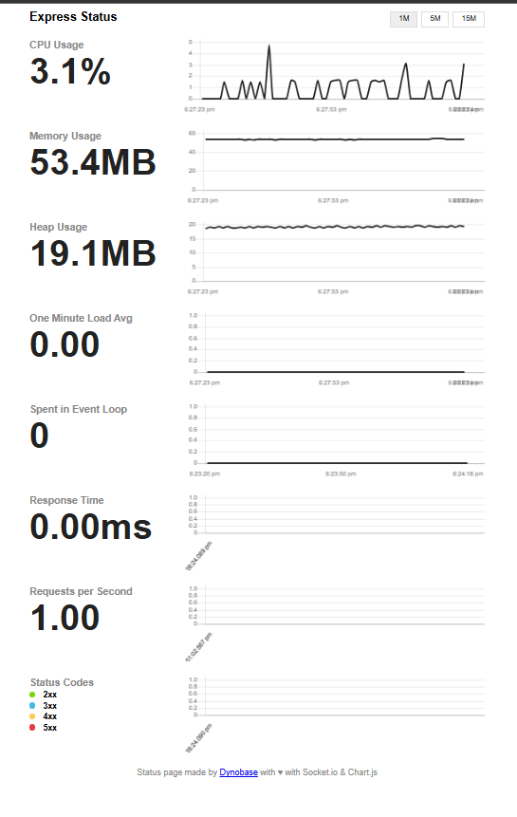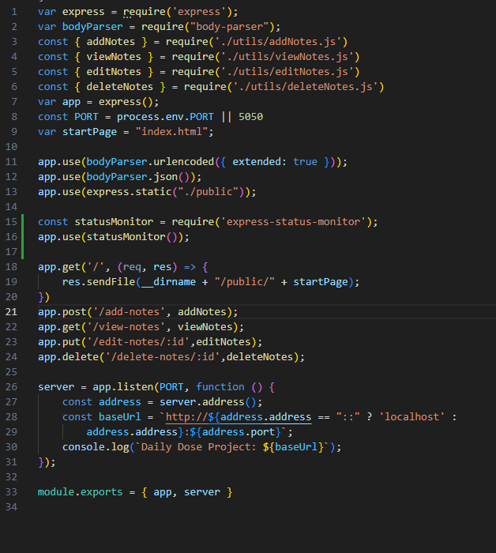
This page shows Express Status Monitor. The left side displays real-time system metrics like CPU, memory usage, event loop latency, and request rates. These help in tracking performance. The right side contains a code snippet from my index.js, added the lien 15 and 16 to get this to display.

Additional Features

Sample Additional Features
Implementation of PM2 + PM2 Monitoring
Implementation of Prometheus + Grafana

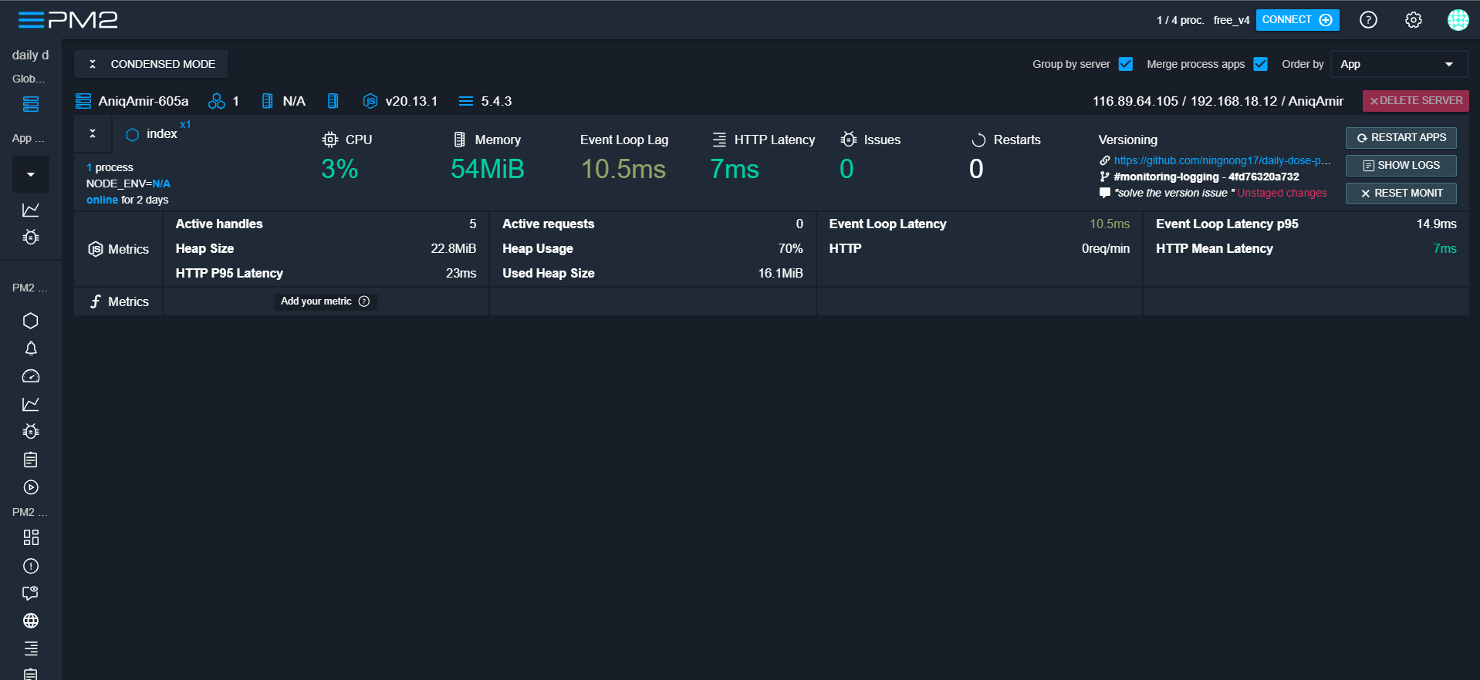

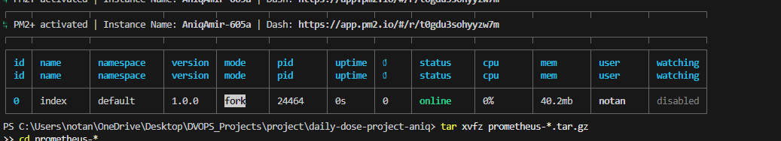
This page highlights PM2 Monitoring enhancements. The PM2 dashboard screenshot shows live resource tracking. The CLI output confirms active processes, memory usage, and uptime, ensuring auto-restarts and optimized performance for a stable CI/CD workflow. I used https://app.pm2.io/ to display my monitoring.

Plan-Perform-Monitor-Reflect (PPMR) Journal
 PLAN
Monitoring Tool: PM2

Ideas/Issues (Topic knowledge)
What I know  - PM2 is a process manager for Node.js applications.  - It provides real-time monitoring, process management, and log tracking.  - It supports auto-restarts and resource usage tracking. | What I don’t know, or  What I need to find out/work on  - How to configure PM2 for detailed monitoring.  - How to use PM2 logs and dashboards effectively.
Action (Identify resources/information)
Get help from  - documentation for PM2 official websites | Resources I should use  - PM2 Official Documentation: https://pm2.keymetrics.io/
Time Management
By when must I complete

- Submission date: 10/2/2024
- Plan to submit by: 9/2/2024
- Plan to do on: 7/2/2024

 PERFORM
Strategies that I am using to
- Monitor progress/keep on task (is the task taking longer than expected?)
I did not procrastinate in doing this

- Locate resource/get help (where & how)
Used PM2 official docs and YouTube

- Check understanding (understand everything I need to understand)
Compared actual results vs. expected outputs

- Motivate myself
- Focused on how PM2 improves deployment and stability.
- Set milestones to track my learning progress.

Resources/Information I have gathered
List down the online resources or books reference you have identified for the fulfillment of the SDL task.
- https://app.pm2.io/
- https://youtu.be/vi-mmPcFSOI?si=gkgAbpdiaG_Bj3Nu
- https://youtu.be/ebdKIU6SDHI?si=mZ2KvKyJHjNgJSeK
- https://pm2.keymetrics.io/

MONITOR
Evaluating Time Management & Potential Information Sources
Tasks Monitoring
- Tracked progress using a checklist for setup, configuration, and testing.
- Adjusted learning pace based on complexity and troubleshooting needs.

Resources Monitoring
- Verified information from official sources and community forums.
- Ensured resources were up-to-date and relevant.

 REFLECT
Write a reflection on your learning
Articulated Learning

- Learned how to configure PM2 for monitoring and process management.
- Improved time management and problem-solving skills.
- Would integrate PM2 with Grafana in the future for deeper insights.

Evaluation
The Plan-Perform-Monitor-Reflect (PPMR) process has helped me to challenge myself towards achieving the desired standards I set for my assignment.
- Strongly agree | - Agree | - Disagree | - Strongly disagree

